Final Data Science Capstone Project
Data Analyst Internship Task 6 of 6
Programme dates 10 October 2026 to 5 December 2026

Problem scope and expected outcome
This project uses the real diabetes cohort distributed with scikit-learn. There are 442 records, ten baseline predictors and one quantitative progression target measured one year after baseline. Raw predictor values are loaded with scaled=False. The scope is educational data analysis and regression, rather than diagnosis or treatment. The same traceable source supports the practical internship tasks, while each report addresses a different objective. The capstone builds a benchmark regression solution and evaluates it against a mean baseline. Deliverables include preparation, EDA, model comparison, held-out predictions, residual plots and stakeholder recommendations.

Data collection and preparation
Load the real cohort with sklearn.datasets.load_diabetes and export raw units. Audit missing values, duplicates and outliers without manufacturing source defects. Preserve valid extreme values. Use the ten existing predictors without additional engineered features for an interpretable benchmark. Pipeline scaling is learned from training subsets only.

Model selection methodology
An 80/20 split uses random_state 42, yielding 353 training and 89 test records. Compare a mean baseline, linear regression, ridge with alpha 10, and a random forest with 200 trees and minimum leaf size 5. Five shuffled training folds use mean absolute error for selection. This prevents choosing the algorithm based on its final test result. Hyperparameter optimization is outside scope.

Held out evaluation
Training cross-validation selected Linear regression. Its test MAE is 42.7941, RMSE is 53.8534 and R squared is 0.4526. MAE measures average absolute error in score units; RMSE penalizes large errors more strongly. R squared compares squared error with the held-out mean reference and is not classification accuracy.

Errors and limitations
The residual chart plots actual minus predicted scores against predictions. Large positive residuals indicate underestimation and negative residuals indicate overestimation. A small cohort and one hold-out split limit certainty. Correlated predictors can destabilize coefficients. The model has no external validation, calibrated prediction intervals or clinical approval. Demographic subgroup checks require additional careful review.

Recommendations and future scope
Use this result as an educational baseline. Add repeated or nested cross-validation if optimizing parameters, inspect subgroup error, and assess independent data before changing scope. Consider prediction intervals and compare alternative models using an agreed protocol. Document any future feature engineering so it remains fitted within training folds.

Reproduction and presentation
Run python run_all.py to regenerate CSVs, charts and evaluation. Notebook 06 explains the comparison and displays prediction errors. The HTML presentation in presentation/capstone_presentation.html summarizes the problem, methodology, findings and limitations. Environment versions are recorded in outputs/results.json.

References and reproducibility
https://scikit-learn.org/stable/modules/generated/sklearn.datasets.load_diabetes.html
Dataset notes and original study attribution are in data/SOURCE.md. The README explains setup, task mapping and submission. Report values are computed outputs, not proof of clinical validity.

Visual evidence
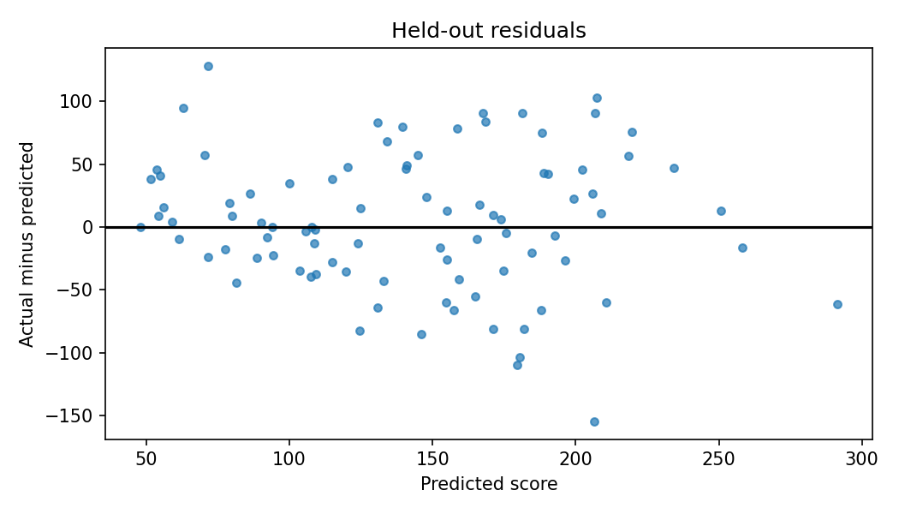
Held-out residuals show errors in progression-score units.

Computed evidence
Model | CV MAE | CV SD
Linear regression | 45.05 | 1.77
Ridge regression | 45.06 | 1.95
Random forest | 47.66 | 2.40
Mean baseline | 66.87 | 5.63

